Hardware Verification Suite (HVS) Launcher

This program is used to run a series of tests in various configurations, and report the overall results to the user. The program allows the user to create various configurations in the form of Saved Games so that it is easy to duplicate a specific test pass across many machines.

Table of Contents

Global HVS Launcher Commands 2
Test List Screen (Main Menu) 3
Rom Flash Menu 6
Test Run Comments Menu 7
Save Suite 9
Load Suite 9
Edit Test (Test Config Menu) 10
Test Results Screen 13
Virtual Keyboard Screen 14
Virtual Keypad Screen 16
Yes / No Screen 17
Help Screen 18
Auto Run feature 19
Configuration File Format (.cfg file) 20

Global HVS Launcher Commands
There are some options that a user can invoke from any menu or screen in the HVS Launcher. They are listed below:

E + F + I (Left Trigger + Right Trigger + Black Buttons)
Pressing the E + F + I button combination will cause the Xbox to reboot. It will perform a ‘warm-boot’ and whatever the default title is will be launched.

E + F + J (Left Trigger + Right Trigger + White Buttons)
Pressing the E + F + J button combination will display an Xbox system information screen. There are many things displayed on this screen, such as amount of memory, version of the MCP or GPU chips, etc. To return to the main menu from this screen, simply press the B button.

Test List Screen (Main Menu)

When the HVS Launcher is started, the first menu that is seen is the test list menu. This menu will list all valid HVS Launcher tests that have been found on the users Hard Drive, or on the HVS Launcher media that has been inserted in to the Xbox.

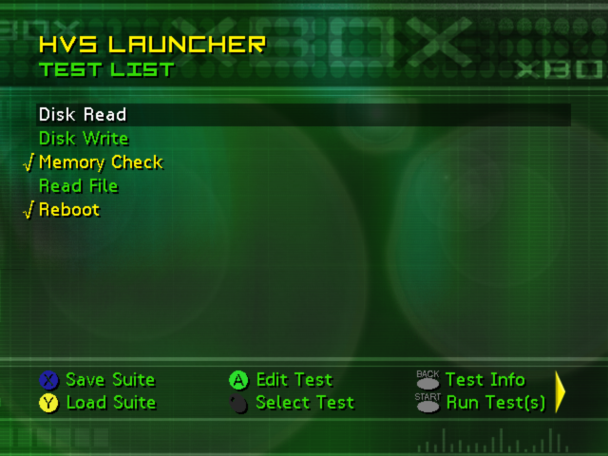

The upper right information is the name of the current Test Suite if you have saved or loaded a Config File. If you have not, there is no information in the upper right.

The menu options are various Tests that are found to be compatible with the HVS Launcher. This will live on the media that the HVS Launcher was started from, either the Xbox Hard Disk, or a DVD / CD-RW disc.

From the main menu, you have several options:

C Save Suite
This option will allow the user to save a set of test configurations that can be loaded and executed from any other machine that contains the HVS Launcher with the same tests. Test configurations are stored on the Xbox as Saved Games, and can either be saved on the Xbox Hard Disk, or on an Xbox Memory Unit. You must have at least 1 test selected in order to use the C button to save a set of test configurations.

D Load Suite
This option will allow the user to load a set of test configurations. Test configurations are stored as Saved Games on the Xbox. They can either be loaded from the Xbox Hard Disk, or an Xbox Memory Unit.

I Select Test
Selected or Deselects the currently highlighted test. Only tests that are selected will execute when the G button is pressed, or be saved when the C button is pressed.

A Edit Test
Pressing the A button will allow the user to edit the currently highlighted tests configurations. The user will be able to modify, create, or delete any test configuration currently associated with the test. If the test you have edited was not previously selected, it will automatically be selected when you press the A button.

H Button
The H button will provide a help screen describing the test. The test creator can place any information they wish on this help screen. If no help information was provided, nothing will happen when you press the H button. While viewing the help you can return to the Test List screen by pressing the B button.

G Run Test(s)
When the user presses the G button, any test that is currently selected will be launched. If a test (or tests) is currently associated with more than 1 configuration, each configuration will be executed for a given test. Once the test run is complete, the test configurations that were executed will be reloaded, and a results screen will be displayed. You must have at least 1 test selected in order to use the G button to launch tests.

J Last Results
After a set of tests have run, a Results screen will appear. It will list generic “Pass / Fail” results for any tests that have been executed. Pressing the J button will display the results screen for the last set of tests that have been executed.

E Flash ROM
Pressing this button will display a menu that allows you to flash a new ROM to your Xbox. You will see a list of available ROMs on the screen, much like the lists of tests that are displayed on the main menu.

F Test Comments
You can associate comments with a test pass or test run. Simply press the F trigger, and you will see an editable menu that allows you to enter some text. Any thing that is entered on this menu will be sent to each test, and that information will be stored in the database (or test results)

Left-Thumbstick Button (Select All / Select None)
The Left-Thumbstick Button can be used to “select all” of the tests. When you press it, if ANY test is not selected, it will select all of the tests. If all of the tests are already selected, then it will de-select ALL of the tests.

Right-Thumbstick Button (Reset HVS Launcher)
The Right-Thumbstick Button can be used to “reset” all of the tests. When you press it, ANY changes made to any tests (added configurations, modified values, etc), will be CLEARED. The HVS Launcher will first ask you if you really want to reset. It will de-select all tests as well when it is finished.

O DPAD Right and K DPAD Left
The menu can only display 6 options at a time. If you see an “arrow” by the menu options, simply press the DPAD Right or Left to see more options.

Rom Flash Menu
The ROM Flash menu will allow you to select a ROM Image that exists on the hard drive or the DVD and then Flash that ROM to your Xbox.

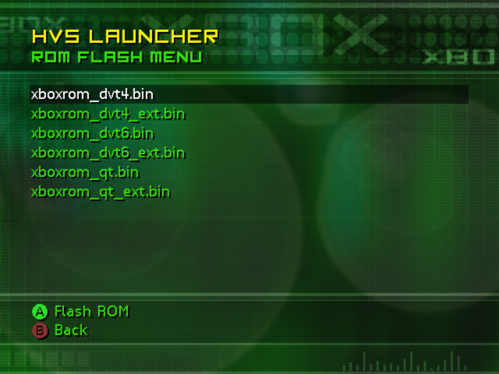

Each menu item is a different ROM Image that was found in the \ROMs directory. There are only two menu choices on this menu:

A Select
Pressing the A button while highlighting a ROM Image will take you to a confirmation screen. The confirmation screen has two options, ‘YES’ or ‘NO’. If you would like to Flash the ROM Image to your Xbox, highlight ‘YES’ and press the A button. If you would like to return to the Flash ROM Menu, eight highlight ‘NO’ and press A, or simply press the B button.

B Back
When you are ready to return to the main menu, simply press the B button.

Test Run Comments Menu
The Test Run Comments Menu will allow you to enter some information specific to the overall test run you are going to execute, and that information will be stored in the database or the test results.

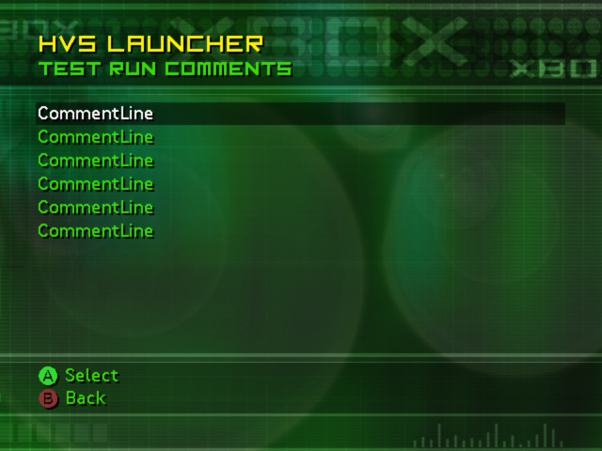

Each ‘CommentLine’ can be edited to contain different information. If you don’t have any test comments, simply leave all of the options blank. There are only two menu choices on this menu:

A Select
Pressing the A button while highlighting most configuration options will allow you to enter a value for that option. If you highlight a “number” option and press the A button, you will be presented with a virtual keypad to enter a new value. If you highlight a “string” option and press the A button, you will be presented with a virtual keyboard to enter a new value. If you highlight a “mixed” option, such as an item with a “number” and a “string”, you will only be able to modify the “number” value with the virtual keypad. To edit the “string” value, please see the “Right Thumbstick” below.

B Back
Once you are finished creating and editing the test run comments, press the B button to return to the main menu.

H Button
The H button will provide a help screen describing what each item is for the test run comments. The user can scroll up and down the list to find out what each item is, and press the B key to return to the Test Run Comments menu.

Right Thumbstick
The right thumbstick is used to configure almost all the menu options. Some menu options can ONLY be changed by using the right thumbstick. Others may use the right thumbstick, or the A button:

Number: Pressing the right thumbstick left or right will cycle through the valid number range for that menu option. That farther you push the stick to the right or left, the fast the value will change.

String: Dynamic strings are NOT affected by the right thumbstick. You have to press the A button to change those values. If they are Static strings (strings that can have only certain values), pressing the thumbstick right and left will scroll through the valid options for that string.

Number String: Some options contain both a number and a string. (i.e. 1 hour(s)). Pressing the right thumbstick to the left and right will change the number portion of the value. Pressing the right thumbstick up and down will change the string portion of the value.

Range: Some options are ranges. (i.e. 10 to 20) Pressing the right thumbstick to the left and right will change the first number of the range. Pressing the right thumbstick up and down will change the second number of the range.

Save Suite
From the main menu, a user can save the current test suite. The “Save Suite” option contains three steps:

- The first step is to configuration and “select” tests that you wish to be a part of the saved test configuration. You do this from the main menu by using the I and A buttons. Once you have completed that, simply press the C button to begin the Save Suite process.

- The second step is naming the Suite Config file. As soon as you press the C button, you will be presented with a virtual keyboard. If you have already saved or loaded a Suite Config file, a name will already appear on the virtual keyboard. If you have not, there will be no name, and you will have to create one. Any name can be entered using a combination of upper case and lower case letters, as well as any symbols. When you are done entering a name, click on the “ok” button to continue.

- The third step is selecting the Memory Area that you wish the file to be stored on. The top of the list will always be the “Xbox Hard Disk”, followed by any Memory Units that are currently inserted. You can insert and remove memory units from any controller at this time, and you will see the list change as new memory units appear, or as memory units are removed. Once you’ve highlighted the Memory Area that you wish to work with, press the A button to create the configuration.

Load Suite
From the main menu, a user can load a test suite. The “Load Suite” option contains two steps:

- To begin the first step, simply press the D button from the main menu. At that time you will be prompted to select a memory area. The top of the list will always be the “Xbox Hard Disk”, followed by any Memory Units that are currently inserted. You can insert and remove memory units from any controller at this time, and you will see the list change as new memory units appear, or as memory units are removed. Once you’ve highlighted the Memory Area that you wish to work with, press the A button to continue.

- The second step is to select the actual Suite Config file you wish to load. Once you’ve selected a Memory Area, you will see a list of all of the Suite Config files that are contained on that Memory Area. Highlight the Suite Config file that you wish to load, and press the A button. At this time you will be returned to the Main Menu, and any tests that were stored in the Suite Config file will be selected.

Edit Test (Test Config Menu)
When a user edits a test from the main menu, they are taken to the “Test Config Menu” menu screen.

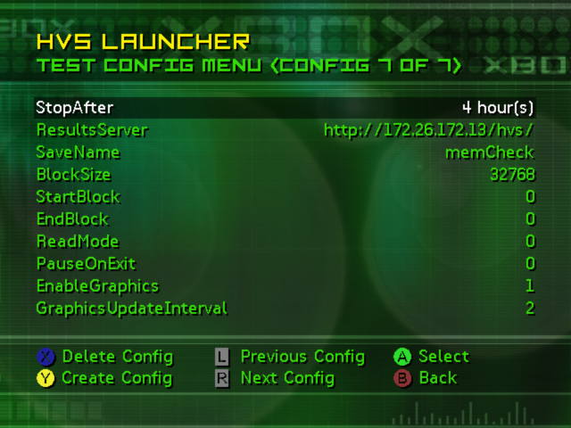

Along the top of the menu, you will see the config information, “(Config # of #)”. This shows how many different configurations there are for the current test, and which configuration we are currently viewing.

The menu items are the various configuration options for the current test. Each test can have a varying amount of configuration options. (Some tests might not have any!) Most have at least one, and many tests have multiple screens worth of options. (Simply move the highlighter to the bottom of the list, and continue to navigate down to see the other items)

Along the bottom of the screen you will see the menu options. They are:

C Delete Config
Pressing this will delete the current test configuration. You must have at least 1 test configuration, so if you press the C button with only 1 test configuration, nothing will happen.

D Create Config
Pressing this will create a new test configuration. For example, if you had a test that contained one test configuration (Config 1 of 1), and you pressed the D button, you would have two test configurations (Config 2 of 2). When a test suite is executed, each test will be run with each different test configuration associated with it. If you had two test configurations associated with a test, that test would be run twice during a test run.

E Previous Config
Pressing the E trigger button will allow you to navigate to a previous test configuration. For example, if you were on the last configuration for a test (Config 3 of 3), and you pressed the E trigger button, you would be on the prior test configuration (Config 2 of 3). Pressing this button when you are on the first test configuration for a test has no effect.

F Next Config
Pressing the F trigger button will allow you to navigate to the next test configuration. For example, if you were on the first configuration for a test (Config 1 of 3), and you pressed the F trigger button, you would be on the next test configuration (Config 2 of 3). Pressing this button when you are on the last test configuration for a test has no effect.

A Select
Pressing the A button while highlighting most configuration options will allow you to enter a value for that option. If you highlight a “number” option and press the A button, you will be presented with a virtual keypad to enter a new value. If you highlight a “string” option and press the A button, you will be presented with a virtual keyboard to enter a new value. If you highlight a “mixed” option, such as an item with a “number” and a “string”, you will only be able to modify the “number” value with the virtual keypad. To edit the “string” value, please see the “Right Thumbstick” below.

B Back
Once you are finished creating and editing test configurations, press the B button to return to the main menu.

H Button
The H button will provide a help screen describing what each item is for the test configuration. The user can scroll up and down the list to find out what each item is, and press the B key to return to the Test Config menu.

Right Thumbstick
The right thumbstick is used to configure almost all the menu options. Some menu options can ONLY be changed by using the right thumbstick. Others may use the right thumbstick, or the A button:

Number: Pressing the right thumbstick left or right will cycle through the valid number range for that menu option. That farther you push the stick to the right or left, the fast the value will change.

String: Dynamic strings are NOT affected by the right thumbstick. You have to press the A button to change those values. If they are Static strings (strings that can have only certain values), pressing the thumbstick right and left will scroll through the valid options for that string.

Number String: Some options contain both a number and a string. (i.e. 1 hour(s)). Pressing the right thumbstick to the left and right will change the number portion of the value. Pressing the right thumbstick up and down will change the string portion of the value.

Range: Some options are ranges. (i.e. 10 to 20) Pressing the right thumbstick to the left and right will change the first number of the range. Pressing the right thumbstick up and down will change the second number of the range.

Test Results Screen
After a Test Suite has been run (executed), the results are presented to the user from the Test Results Screen.

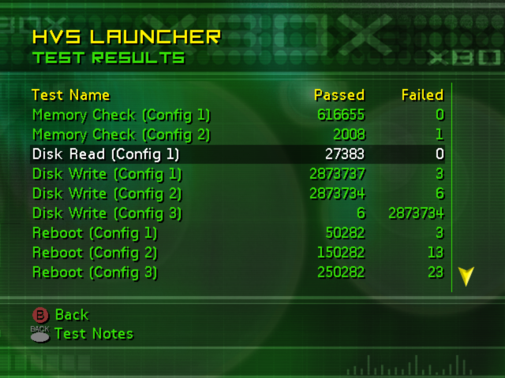

The menu items on the Test Results screen are simply Test Names, the config number information, and how many passes or failures occurred for that particular test config. If there are more tests than would fit on one screen, you would simply navigate down the menu using the left thumbstick, and the menu items would scroll once you reached the bottom.

There are two options available to you from the test results screen:

B Back
Pressing the B button will take you back to the main menu.

H Button
The H button will display any notes that a test passed back to the HVS Launcher. These notes can be anything that the test thinks is important. (Failure information, hardware data, etc). If the test did not pass back any notes, pressing the H button will do nothing. Pressing the B button when viewing the notes will return you to the Test Results screen.

Virtual Keyboard Screen
The virtual keyboard screen allows the user to enter dynamic input for various menu options and values.

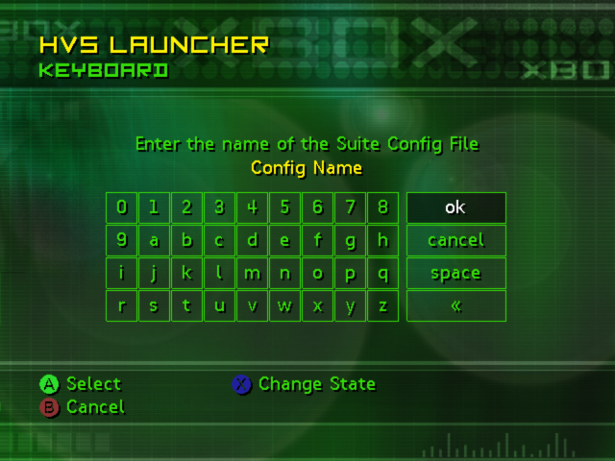

There are other shortcut keys available to perform various options. All the information is below:

A Button
Use this to insert a character at the end of the string, or to use on the navigation buttons on the right hand side of the menu. Simply highlight the item you wish to use and press the A button.

B Button
Use the B button to cancel the current input and return to the previous menu. Pressing the B button is the same as highlighting the “cancel” option and pressing A.

C Button
Use the C button to change the state of the keyboard. There are three states that the keyboard can have: Alpha letters lowercase, Alpha letters uppercase, and Symbols. Each time you press the C button the keyboard will shift to a new state.

J Button
The J button is used for backspace. Pressing the J button will remove the very last character from the current string. Pressing the J button is the same as highlighting the “«” option and pressing A.

I Button
The I button is used for space. Pressing the I button will insert a space character at the end of the current string. Pressing the I button is the same as highlighting the “space” option and press A.

Left-Thumbstick Button
The Left-Thumbstick Button is the same as a computer “Shift” key press. It will change temporarily change the state of the keyboard. If the keyboard is in Alpha letters lowercase state, it will change to Alpha letters uppercase. If it is in Alpha letters uppercase state, it will change to Alpha letters lowercase. It will remain in this state for one key press, after which time it will revert back to the previous state.

Virtual Keypad Screen
The virtual keyboard screen allows the user to enter dynamic input for various menu options and values.

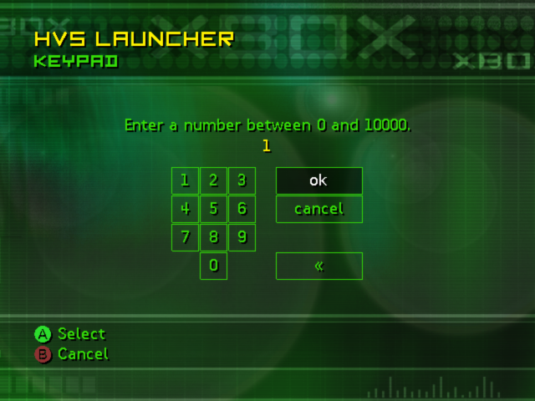

There are other shortcut keys available to perform various options. All the information is below:

A Button
Use this to insert a character at the end of the string, or to use on the navigation buttons on the right hand side of the menu. Simply highlight the item you wish to use and press the A button.

B Button
Use the B button to cancel the current input and return to the previous menu. Pressing the B button is the same as highlighting the “cancel” option and pressing A.

J Button
The J button is used for backspace. Pressing the J button will remove the very last character from the current string. Pressing the J button is the same as highlighting the “«” option and pressing A.

Yes / No Screen
The Yes / No screen allows the user to enter either YES or NO to a specific question.

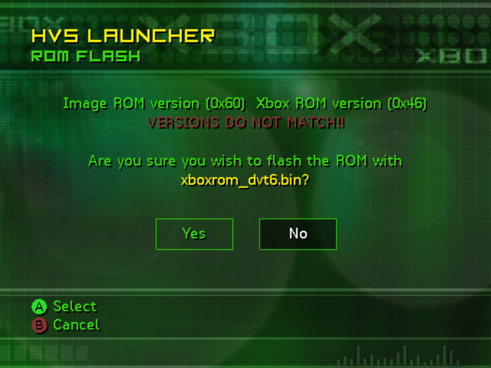

The Yes / No screen has dynamic elements that will change depending upon the situation. The title line, underneath the “HVS Launcher” heading, will change depending upon the user action. (i.e., Flashing a ROM Image as in the image above). The text above the Yes / No buttons will also change.

There are two options available to the user from this menu:

A Button
A user will navigate left or right to select either YES or NO. Once the selection is made, pressing the A button will accept the choice and move on to the next menu. To answer “YES” to the question, simply highlight the “YES” option and press the A button. To answer “NO” to the question, simply highlight the “NO” option and press the A button.

B Button
Use the B button to cancel the current input and return to the previous menu. Pressing the B button is the same as highlighting the “NO” option and pressing the A button.

Help Screen
The help screen can be launched from several places in the HVS Launcher.

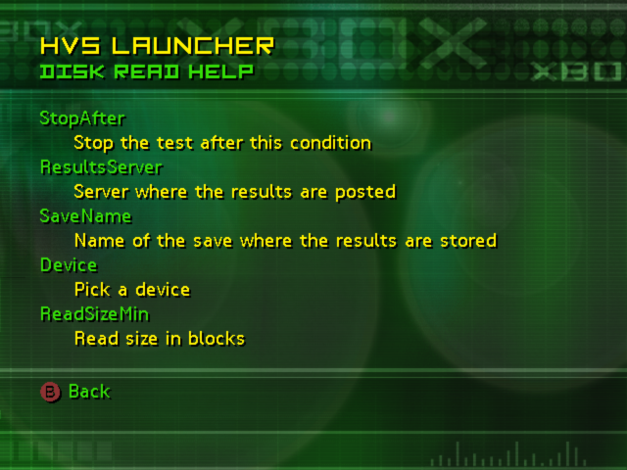

The help screen title will change depending upon what type of help you are viewing. For the above screen-shot, the “Disk Read” test configuration was being viewed when help was invoked.

These are the buttons that are used for the help screen navigation:

B Button
Use the B go back to the previous screen. This will normally return you to the screen from where you pressed the help button.

Left-Thumbstick / DPad Up and Down
You can navigate the help screen by moving the Left-Thumbstick or DPad Up and Down. Pressing the down control will scroll the screen up by 1 line. Pressing the up control will scroll the screen down 1 line.

Right-Thumbstick Up and Down
You can navigate the help screen one page at a time by moving the Right-Thumbstick Up and Down. Each time you press the Right-Thumbstick Up it will scroll the screen down by 10 lines. Each time you press the Right-Thumbstick Down it will scroll the screen up by 10 lines.

Auto Run feature
The HVS Launcher has a feature called “Auto Run”. This feature will allow you to automatically have a Test Config file loaded and executed when the HVS Launcher is started. This is extremely handy if you want to copy over many tests to various Xboxes, and have them all execute a Suite of Tests.

To you use this feature, you must copy a file named AUTORUN.TXT over to the T:\ drive of the HVS Launcher. The full path on the Xbox C partition is “C:\TDATA\48570000\AUTORUN.TXT”. This file should contain only one line of information. It is a comma delimited line that contains the drive letter of the Memory Area of the test configuration you wish to load, and name of the test configuration surrounded by double quotes. Here is an example:

U:\, "HD Tests"

The U:\ instructes the HVS Launcher to look on the Xbox Hard Disk for the saved test configuration. The “HD Tests” tells the HVS Launcher to look for saved test configuration named “HD Tests”. The drive paths are as follows:

U:\ - Xbox Hard Disk
F:\ - Memory Unit 1A
G:\ - Memory Unit 1B
H:\ - Memory Unit 2A
I:\ - Memory Unit 2B
J:\ - Memory Unit 3A
K:\ - Memory Unit 3B
L:\ - Memory Unit 4A
M:\ - Memory Unit 4B

If the HVS Launcher finds this file, it will attempt to load the specified test configuration, and launch those tests. It them immediately deletes the file AUTORUN.TXT, so that the tests will only execute once. After the tests are finished running, the configurations that were executed will be re-loaded in to memory, and the “Test Results Screen” will be presented to the user with the Pass / Fail information for the tests.

Configuration File Format (.cfg file)
Each test that can be executed by the HVS Launcher needs to have a configuration file (.cfg file) to tell the HVS Launcher how and what to modify for this test. The configuration file must contain a version number, and some configuration options (described below). It may also contain comments, which will be ignored.

Here is an example configuration file, which all possible types of configurable options:

1 ; config version

;
; Example Test Config File
;

; Config Items
Device, "Pick a device", string, Hard_Disk, CD_ROM, Floppy
SaveName, "Name of save", string2, "examTest"
StartLBA, "Starting block address", number, 0, 0, 9999999
StopAfter, "Stop after condition", numberstring, 1, 0, 10000, hour(s), minute(s), iteration(s)
Exclude, "Exclude blocks", range, 0, 0, 9999999, 0, 0, 9999999

Starting at the top, you will see a “Version”. Each config file should contain a version number. Whenever the config file is updated, this version number should be incremented. This number can be used to protect against errors or failures when a saved configuration is loaded for an older version of a test.

You then seem some “comment” lines. Comments are marked with a semi-colon (;), and can appear on lines by themselves, or at the end of other lines (such as config item lines). They are simply ignored when the config file is loaded.

When a value is actually passed to a test, only the Item Name and Item Value is passed along. It is passed as:
ItemName = ItemValue

The 5 types of config items are:

String:
A “string” is actually a string list. If an item has a “string” as its value, but it’s a very specific string, this type should be used. In the above example, the only valid strings for the item “Device” are “Hard_Disk”, “CD_ROM”, and “Floppy”. The user will be allowed to select only one of these three options while configuring the test.

Item Name | Help Text | Item Type | Item Values
Device, | “Pick a device”, | String, | Hard_Disk, CD_ROM, Floppy

String2:
A “string2” is actually a free-form String. This should be used when a value can contain any valid string input. In the above example, the item “SaveName” is a string, and it’s default value is “examTest”.

Item Name | Help Text | Item Type | Item Value
SaveName, | “Name of Save”, | String2, | "examTest"

Number:
A number is simply a number that has a range associated with it. In the configuration file you specificy the minimum, maximum, and default value of the number.

Item Name | Help Text | Item Type | Default | Min | Max
StartLBA, | “Starting block address”, | Number, | 0, | 0, | 9999999

NumberString:
A “numberstring” is a combination of a number and a string. You specify a default, min, and max value for the number, and you specify each value that the string portion of the numberstring could be.

Item Name | Help Text | Item Type | Default | Min | Max | String Values
StopAfter, | “Stop after condition”, | Numberstring, | 1, | 0, | 10000, | Hour(s), minutes(s), iterations(s)

Range:
A range consists of two number values. Each number value has a default, minimum, and maximum value associated with it.

Item Name | Help Text | Item Type | Default 1 | Min 1 | Max 1 | Default 2 | Min 2 | Max 2
Exclude, | “Exclude blocks”, | Range, | 0, | 0, | 9999999, | 0, | 0, | 9999999

